БЕЛОРУССКИЙ ГОСУДАРСТВЕННЫЙ ТЕХНОЛОГИЧЕСКИЙ УНИВЕРСИТЕТ

ФАКУЛЬТЕТ ИНФОРМАЦИОННЫХ ТЕХНОЛОГИЙ

**Лабораторная работа №13**

По конструированию программного обеспечения

**Выполнил:** Станчик Максим Андреевич, ФИТ, 1 курс 4 группа ПОИТ, 2 подгруппа

**г. Минск**

**2023 г.**

#2 Регулярное выражение моего варианта:

|  |  |  |
| --- | --- | --- |
| |  | | --- | | while(□)*(read+seek)*□+do{write□*}; | |  | |

while=a

□=b

read=c

seek=d

do=e

;=u

write=f

{=i

}=g

Регулярное выражение моего варианта с новыми обозначениями:

a(b)*(c+d)*b+ eifb*gu

#3 Примеры цепочек:

1. A b d b e i f b g u
2. A b d e i f g u
3. A bbb d b e I f b g u
4. A b e i f g u
5. A bb e i f bbb g u
6. A bbb ddd b e i f b g u
7. A b d b e i f b g u

a(b)*(c+d)*b+ eifb*gu

#4

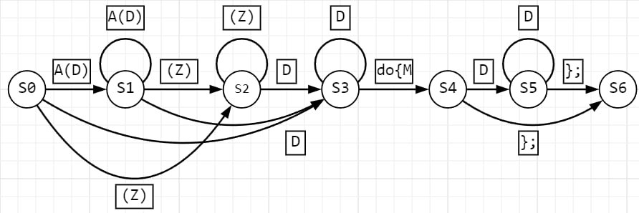

|  |  |  |  |  |  |
| --- | --- | --- | --- | --- | --- |
|  | A(D) | D | (Z) | do {M | }; |
| S0 | S1 | S3 | S2 | \\\\\\\\\\\\\\\\\\\\ | \\\\\\\\\\\\\\\\\\\ |
| S1 | S1 | S3 | S2 | \\\\\\\\\\\\\\\\\\\\ | \\\\\\\\\\\\\\\\\\\ |
| S2 | \\\\\\\\\\\\\\\\\\\\ | S3 | S2 | \\\\\\\\\\\\\\\\\\\\ | \\\\\\\\\\\\\\\\\\\\ |
| S3 | \\\\\\\\\\\\\\\\\\\\ | S3 | \\\\\\\\\\\\\\\\\\\\ | S4 | \\\\\\\\\\\\\\\\\\\\ |
| S4 | \\\\\\\\\\\\\\\\\\\\ | S5 | \\\\\\\\\\\\\\\\\\\\ | \\\\\\\\\\\\\\\\\\\\ | S6 |
| S5 | \\\\\\\\\\\\\\\\\\\\ | S5 | \\\\\\\\\\\\\\\\\\\\ | \\\\\\\\\\\\\\\\\\\\ | S6 |
| S6 | \\\\\\\\\\\\\\\\\\\\ | \\\\\\\\\\\\\\\\\\\\ | \\\\\\\\\\\\\\\\\\\\ | \\\\\\\\\\\\\\\\\\\\ | \\\\\\\\\\\\\\\\\\\\ |

#5

4. a b e i f g u => b e i f g u => e i f g u => i f g u => f g u => g u => $λ$